
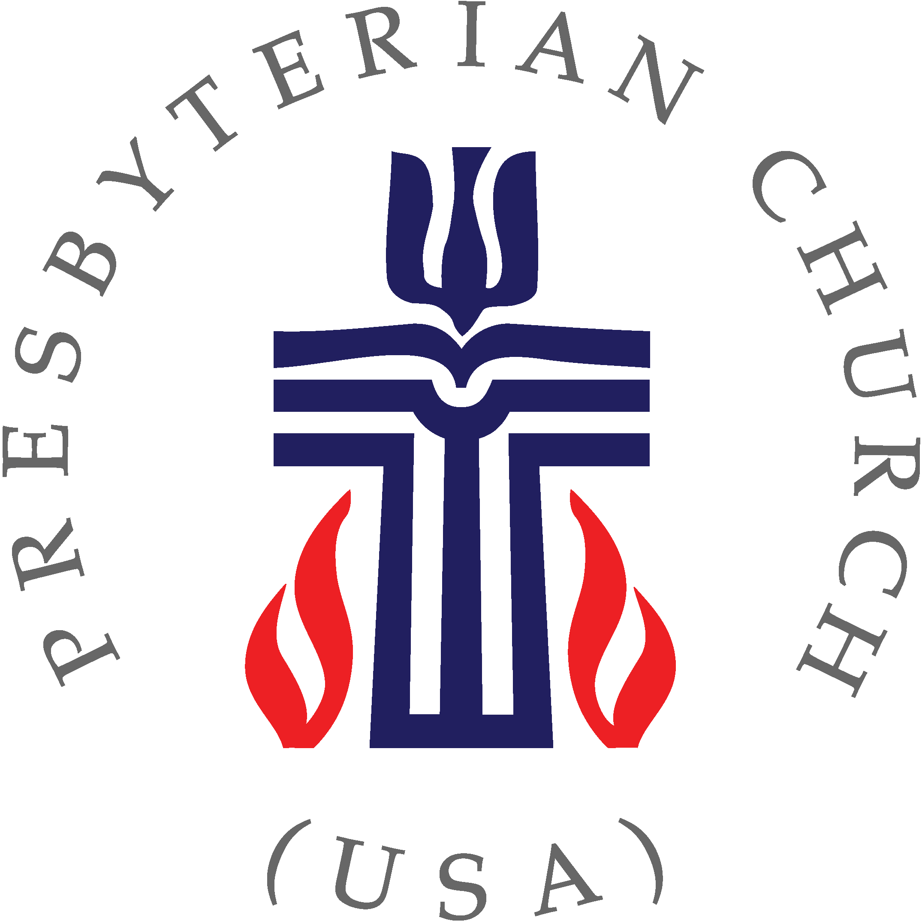
Presbytery of Riverside

CALL for the STATED MEETING of the
PRESBYTERY OF RIVERSIDE

SATURDAY, November 8, 2025 – 10:00 am
In-Person Only Meeting

Riverside Presbytery: connecting and supporting
pastors, leaders, and congregations in Christ’s transforming love.
(Mission Statement Presbytery of Riverside)

TO: All Ministers, Elder Commissioners, and Clerks of Sessions
FROM: Teaching Elder Paul Knopf, Stated Clerk

The Sovereign God, in the name of Jesus the Christ, through the power of the Holy Spirit,
is calling the Presbytery of Riverside to gather together to hold its Stated Meeting on

SATURDAY, November 8, 2025 at 10:00 am
In-Person at Magnolia Presbyterian Church, Riverside
(7200 Magnolia Ave., Riverside, CA 92504)

Registration Required: please register for the meeting using this link:
Register Now
We are using zoom to register for the meeting. This meeting is in-person only.

The meeting is scheduled to begin at 10:00 am and conclude with lunch around 1:30 pm

Please register by Noon on November 5th, to help determine if a quorum will be present
*LUNCH RESERVATIONS ARE REQUIRED by Wednesday, November 5th*
Cost for lunch: $10

Snacks/Breakfast will be available before and during the meeting (for all) and lunch will be provided for those who make a reservation. Vegan and vegetarian options will be available.

Questions? Please contact Jim Strand at (909) 881-1595 or e-mail at riversidepresbytery.info@riversidepresbytery.com

The Offering has been designated to support Family Promise of Riverside
Offerings can also be made by using this link: Donate Now

Packet of materials for this meeting will be emailed to commissioners on Friday, October 31st

We look forward to seeing you at the Saturday, November 8th Assembly, in-person!
PO Box 1561, San Jacinto, CA 92581 | 100 Cajon St, Redlands, CA 92373 | (909) 881-1595 | www.riversidepresbytery.com

Some highlights of this Presbytery Assembly Meeting
PO Box 1561, San Jacinto, CA 92581 | 100 Cajon St, Redlands, CA 92373 | (909) 881-1595 | www.riversidepresbytery.com

- Spirit-inspired worship led by the team at MagPres with a sermon by the Rev. Alfred Graise, outgoing Moderator
- Celebration of the Lord’s Supper as a Presbytery and the Necrology
- Elect Commissioners to the 2027th General Assembly (2026)
- The Presbytery Commission will present a proposed budget for 2026 and PFIFD will share how this budget was put together
- The Committee on Nominations and Representation will present a slate of nominees for presbytery committees and a Vice-Moderator
- The Presbytery Commission will present nominees for the Committee on Nominations and Representation
- The Committee on Ministry will present two Pastors for examination to receive a call (One for Palm Springs Presbyterian Church and one for First Presbyterian Church of San Bernardino)
- Receive a report from the Triennium Delegation
- Connect with presbyters and friends from across the presbytery
- and more…

Magnolia Presbyterian Church is located at 7200 Magnolia Ave., between Madison St and Arlington Ave. Heading northbound on Magnolia Ave., from Madison St. toward Arlington Ave., take a slight Right into a deceleration lane and an immediate right into our main parking lot (green box below). After parking, walk along Magnolia Ave., past our construction zone, to our Worship Center (which is the oldest Church Building in Riverside; Historic Landmark #4).
For those with limited mobility, continue on the deceleration lane, past the main parking lot, until you reach the small parking lot (blue box below), right in front of our Worship Center.
